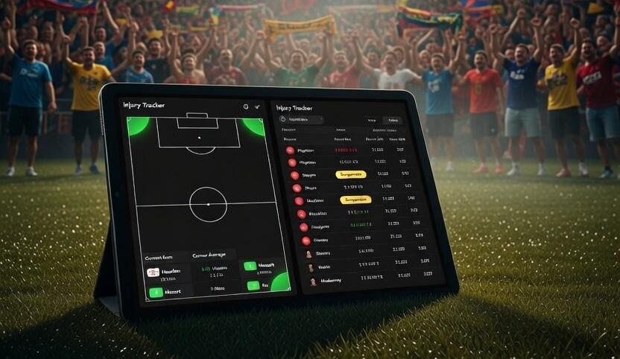
The Injury List Is Public. The Impact Isn’t.
Corners Intelligence & Injury Suspension Tracker — coming soon to Silver members

Every manager knows who’s missing before kick-off. Every bookmaker knows too. Their lines move the moment a team sheet drops — quietly, efficiently, and in their favour.
The average punter finds out at 7:45pm when the lineups appear on the BBC Sport app. By then the odds have already moved. The value has gone. And if you’ve already placed your bet, you’re hoping for a miracle from a side missing their first-choice striker and their most creative midfielder.
That’s not bad luck. That’s an information gap. And it’s one we’re closing.

Two New Tools. Two New Edges.
We’re releasing our next batch of Research Hub tools very soon — exclusively for Silver members. Corners Intelligence and the Injury & Suspension Tracker are the next two tools joining The Edge. Here’s what they do, how they work, and why we built them the way we did.

Corners Intelligence
Corners are one of the most underrated and consistently profitable markets in football betting. Not because the value isn’t there — it absolutely is — but because most punters don’t have the data to identify it quickly enough or trade it with any real confidence.
The truth is that corner patterns are among the most repeatable things in football. The same teams rack up corners week after week. The same grounds produce the same dynamics. Home sides with high-press, attack-minded styles average 7, 8, even 9 corners per game with remarkable consistency across an entire season.
Meanwhile, some away sides are so defensively disciplined — sitting deep and hitting on the break — that they barely win a corner all game regardless of the opposition. These are known quantities. The data is all there. Most punters just don’t have time to dig through it before kick-off. Our Corners Intelligence tool does that digging for you, automatically.
Whether you’re looking at Over 9.5 Corners as a pre-match single, trading the corners market in-running, or building a corners accumulator across multiple games, this tool gives you the numbers before the bookmakers have finished pricing them in.
What the tool covers:
- Average corners per game: Home and away tracked separately, not just combined averages that hide the real picture
- High-corner fixtures: The full fixture list ranked by expected corner volume so the best opportunities float to the top
- League-by-league breakdown: Because the Bundesliga and the Championship are completely different animals when it comes to corners
- Trend data: Based on recent form, not just season averages, so a team that’s changed system or manager is reflected accurately
- Team profile flags: Aggressive pressers, deep-sitting defences, and set-piece specialists all identified
Corners is a market where consistency beats guesswork every single time. Bookmakers price corners quickly and efficiently because the underlying data is available to them. This tool puts that same data in your hands before you place a single bet.

Injury & Suspension Tracker
“This one is personal.”
There is nothing more avoidable in football betting than backing a team whose key striker is suspended, only to find out when the lineup drops twenty minutes before kick-off. It happens to every punter. It’s happened to Guru more times than he’d like to admit. And every single time it’s happened, the information was out there — just not in one place, and not easy to act on quickly.
The Injury & Suspension Tracker changes that. It pulls confirmed and reported absences from across all major leagues and organises them into one clean, scannable dashboard — updated daily. Before you back a selection, before you build an accumulator, before you trade a game in-running, you check the tracker.
Beyond just listing who’s out, the tracker is built to help you understand the impact. A goalkeeper being out matters less than a striker who scores or assists every other game. A holding midfielder’s suspension matters differently depending on the system. The tracker gives you context alongside the absence so you can make a proper decision, not just a panicked one.
What the tracker covers:
- Confirmed injuries: Players definitively ruled out, with injury type where reported
- Suspensions: Red card bans, accumulative yellow card suspensions, cup tie ineligibilities and international call-up conflicts
- Doubtful: Players listed as uncertain or in a race against time, flagged separately so you know the difference
- Return dates: Where confirmed or estimated, so you can plan ahead across multiple game weeks
- Position and role: Because the impact of an absence depends entirely on how important that player is to how their team functions
- Recent form context: So you’re not just seeing a name but understanding whether their absence genuinely weakens the side

Why These Two Together
Corners and injuries sound like they belong in separate conversations. In practice they’re more deeply connected than most punters realise. When a team loses a physical, pressing centre forward, they often drop deeper and defend more conservatively — their corner count drops. When a combative defensive midfielder is suspended, teams around them become less organised under pressure and concede more corners.
When a dominant attacking full-back is out, that entire flank loses its width and crossing threat. The Injury & Suspension Tracker and Corners Intelligence tool genuinely work better together. Run both before every selection and the picture you get is dramatically more complete than either one gives you alone. That’s not an accident — we built them with that cross-reference in mind.

How They Fit Into The Edge
With these two tools joining The Research Hub, Silver members will have access to 16 live data tools built on the same API data and model infrastructure the bookmakers use every single day. Every morning the model runs. Every morning the data updates. Every morning you have what you need before the first kick-off of the day.
The bookmakers have had this infrastructure for years. Most tipster services have none of it. We built The Edge to close that gap permanently — and every tool we add makes it harder for the bookies to hide.

Join the Ride
We currently have 14 powerful tools live in The Research Hub for Silver members. These two are coming very soon.
Silver membership is still available at our ridiculously low Early Bird launch price of £99 per year (billed annually). It remains our most popular tier for very good reason. These special rates are our way of rewarding our founding supporters. You all hold a very special place in our hearts.
Who’s joining the ride?
https://www.betting4profits.co.uk/membership

Please gamble responsibly. 18+ only. BeGambleAware.org | GamCare.org.uk

